

SYSTEMS ANALYSIS AND DESIGN

PROJECT A5MMS

Lopez, Carlucenne

Naperi, Jayson

Dela Cuesta, Georgette

Rocero, Earl Jerome

**Team Members**

Ms. Rhea Luz Valbuena

**Professor**

**Table of Contents**

1. **Business Case**………………………………………………………………………………………………………………………**3**
2. Purpose……………………………………………………………………………………………………………………………….3
3. Project Overview…………………………………………………………………………………………………………………3
4. Objectives of the Proposed System……………………………………………………………………………………. 3
5. Review of Related Study / Software…………………………………………………………………………………….4
6. Organizational Chart……………………………………………………………………………………………………………4
   1. Agency Organizational Chart…………………………………………………………………………………..4
   2. Team Organizational Chart…………………………………………………………………………………….5
7. Roles & Responsibilities……………………………………………………………………………………………………...5
8. Gantt Chart……………………………………………………………………………………………………......................5
9. Cost & Benefit…………………………………………………………………………………………………….................6
   1. Tangible Benefit vs. Intangible Benefit…………………………………………………………………..6
   2. Labor Cost……………………………………………………………………………………………………………..7
   3. Development Cost………………………………………………………………………………………………...7
   4. Operational Cost……………………………………………………………………………………………..…... 7
10. Scope and Limitations………………………………………………………………………………………………………..8
11. Risk Management……………………………………………………………………………………………….……………..8
12. Success Factors……………………………………………………………………………………………………………….… 8
13. **Diagrams**………………………………………….………………………………….…………………………………………….9
14. Functional Decomposition Diagram……….…………………………………………………………………….…….9
15. Context Diagram………………..……….……………………………………………………………………………….…….9
16. Data Flow Diagram (Diagram 0) ………………..……….……………………………………………………….……10
17. Entity – Relationship Diagram………………..……….…………………………………………………………..……10
18. Use Case Diagram ………………..……….…………………………………………………………..……………………..11
19. Use Case Narrative Description ………………..……….……………………………………………………………..11
20. Object Diagram ………………..……….……………………………………………………………………………………..15
21. Sequence Diagram ..………………..……….…………………………………………………………………………......15
22. State Transition Diagram ..………………..……….……………………………..………………………………….....18
23. Activity Diagram ..………………..……….……………………………..…………………………………..................20
24. Software Requirements Specifications Checklist ..………………..…………………………..................21
25. **BUSINESS CASE**

**Purpose**

Ease the application, employment and payroll transactions of the applicants, employees and clients.

**Project Overview**

A5MMS is a corporation, formed and organized under the laws of the Republic of the Philippines, duly registered with the Security and Exchange Commission (SEC) and licensed to operate a manpower/janitorial services.

Human Resources Management System (HRMS) is a software application that combines many human resources functions including application, employment and payroll and review into one package.

**Objectives of the Proposed System**

To enhance the application, employment and payroll transactions of the agency.

To provide the agency, a human resource management system that have these modules:

* HR Management Module
  + Applicant Module
    - Records of applicant’s information and submitted resume
  + Job Vacancy Module
    - Records of vacant job details
  + Employment Module
    - Records of employment details
* Payroll Module
  + Automates the pay process by gathering data or employee time & attendance, calculating various deductions & benefits, and generating employee pay slip and payroll.

**Review of Related Study / Software**

**Global Data Systems** – is recognized as a leading provider of telecommunications and technology solutions. They were using a hybrid model of a payroll system with some of its HR functionality as well as a paper based model for all of their HR management. The hiring process was highly manual causing a great deal of confusion and managing all of the HR functions was not scalable. They wanted an HRIS system to bring all of the HR functions under one umbrella.

|  |
| --- |
| **HRPayrollSystems.net (free online)** |
| * Highly responsive to the client’s needs * Saved massive research headache * Reduced the field quickly & effectively * Identified HRIS vendors that matched their needs * Identified an HRIS vendor that provided the needed customer service * Received the greatest amount of value from their selected HRIS with respect to budget |

**Organizational Chart**

**Agency Organizational Table**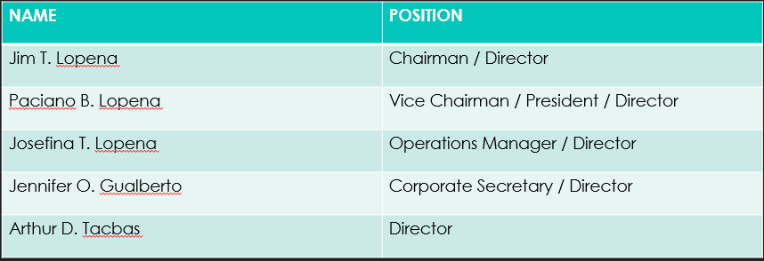

**Team Organizational Chart**

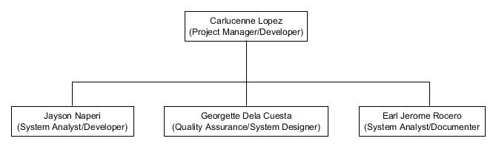

**Roles & Responsibilities**

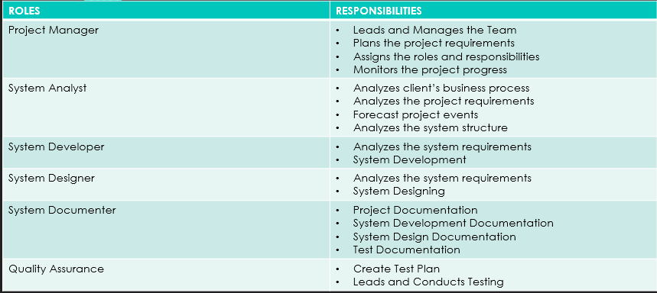

**Gantt Chart**

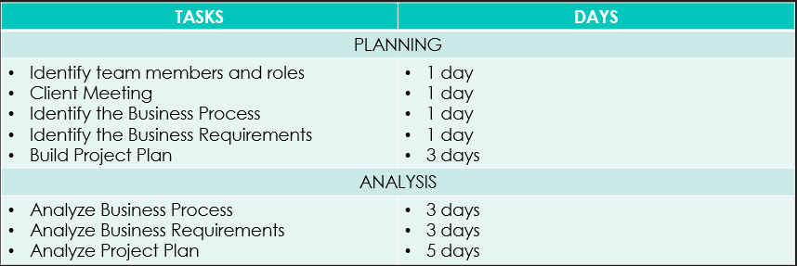

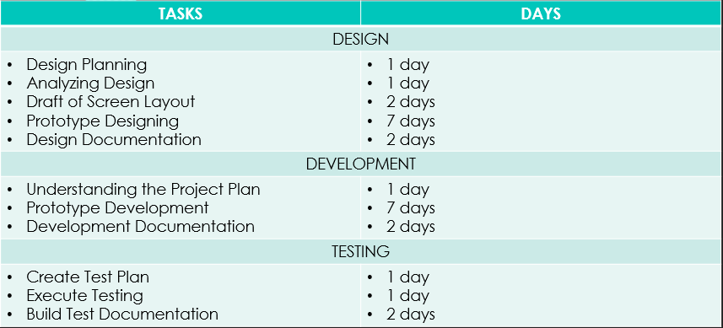

**Cost & Benefit**

**Tangible Benefit vs. Intangible Benefit**

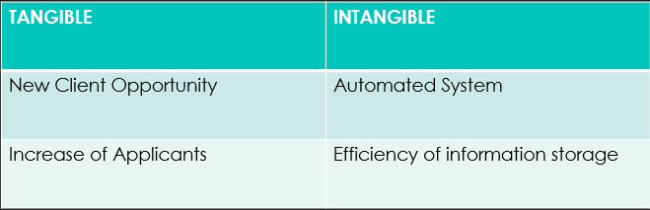

**Labor Cost**

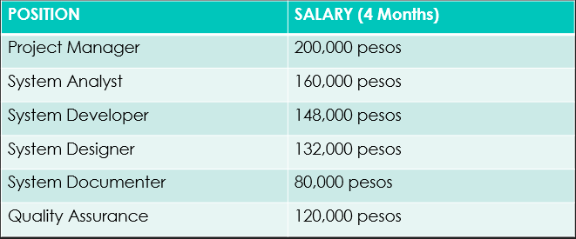

**Development Cost**

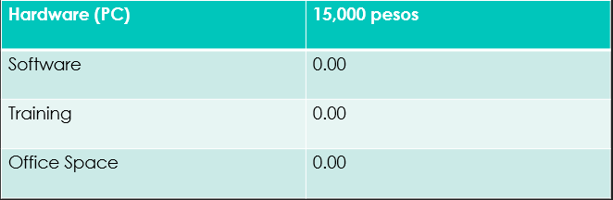

**Operational Cost**

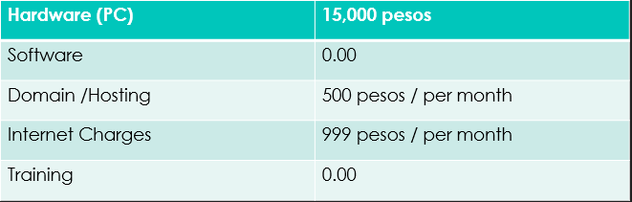

**Scope & Limitations**

The system will be integrated into 3 parts: The Human Resource Module, The Accounting Module and the Website. The HR Module and the accounting module is an internal system while the website is an external system and can be only managed by the admins. Each module has their own set of databases (for the accounting and the HR modules) and its own admin control accounts. The accounting module generates the payroll of the employees using the biometrics send by the company while the HR module handles the information of their applicants and employees. In the website, the company’s basic information is shown and the list of job openings. The main purpose of the website is to provide easier ‘applicant’ to ‘agency’ transaction by letting the applicant upload their resume through the website for the agency to review.

**Risk Management**

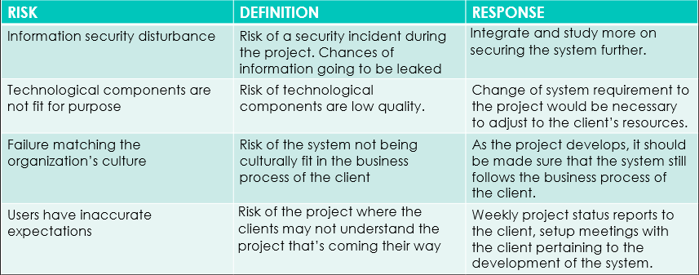

**Success Factors**

* Successfully view the available job details
* Successfully inputted information and uploaded resume
* Successfully login to the system
* Successfully manages the HR Module appropriately
* Successfully generates and computes payroll

1. **DIAGRAMS**

**Functional Decomposition Diagram**

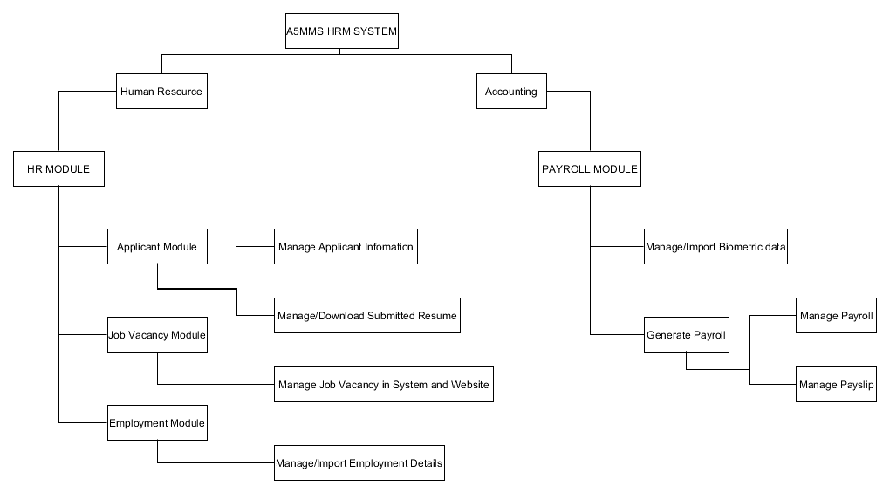

**Context Diagram**

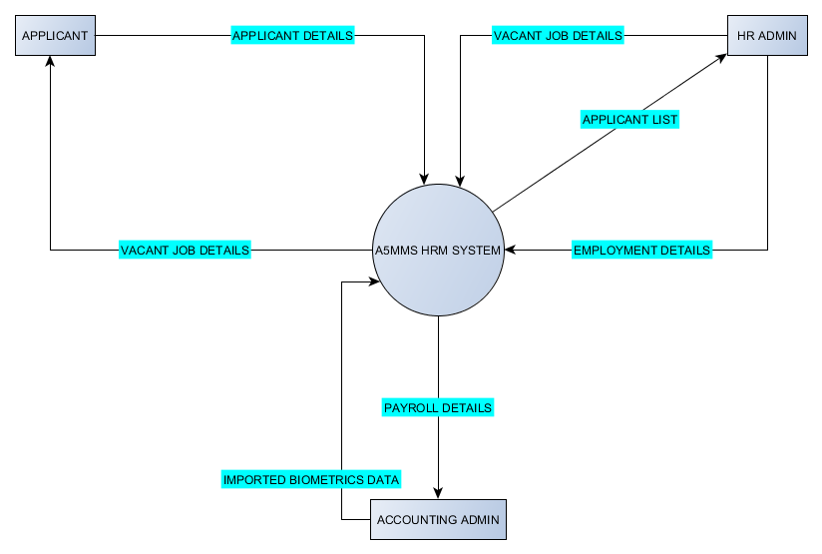

**Data Flow Diagram (Diagram 0)**

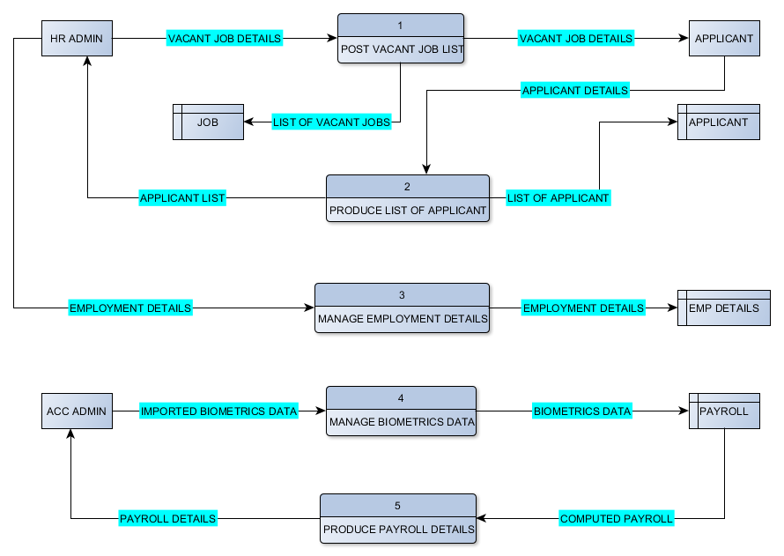

**Entity – Relationship Diagram**

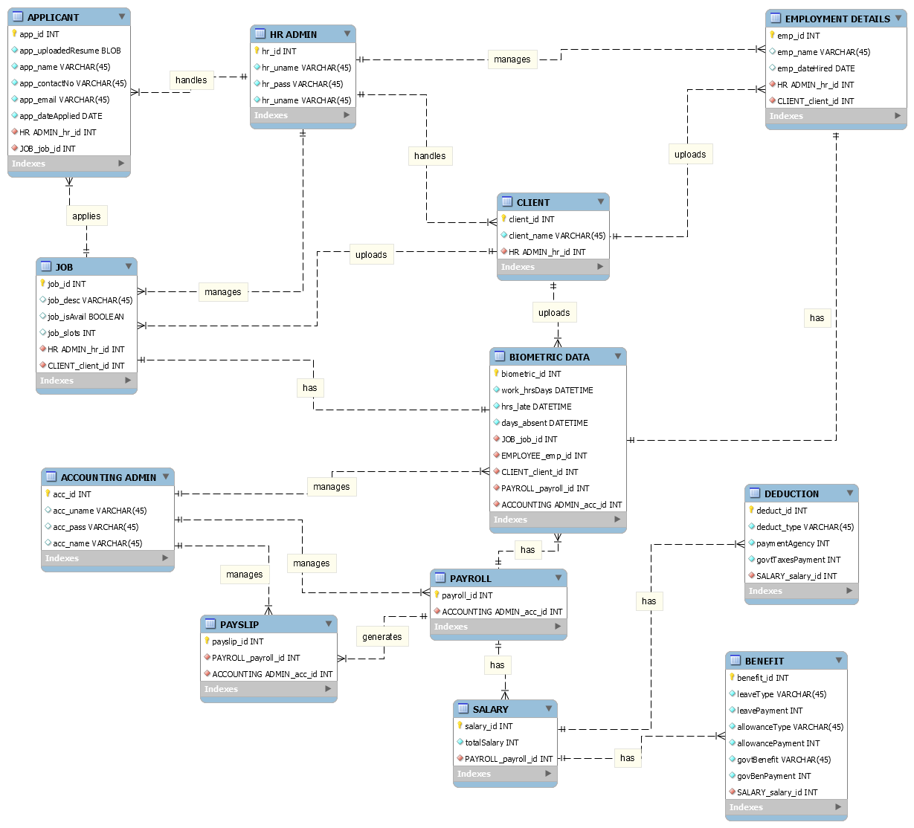

**USE CASE DIAGRAM**

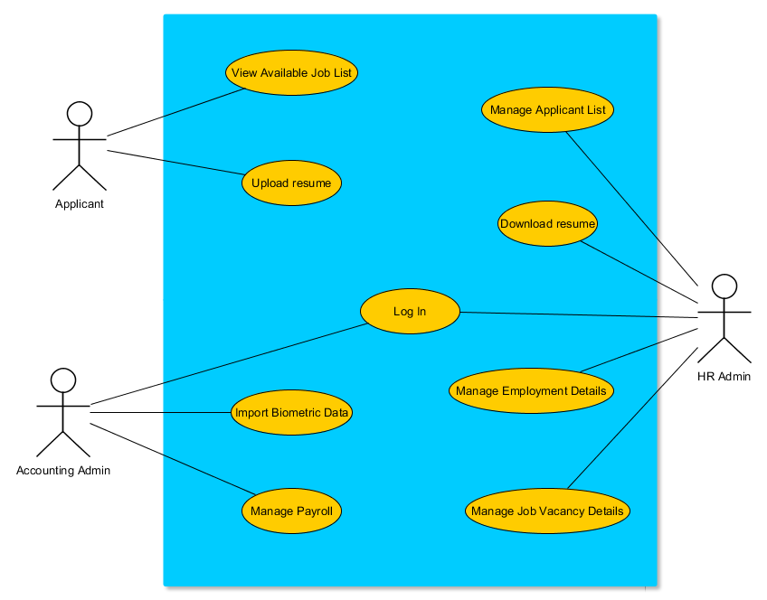

**USE CASE NARRATIVE DESCRIPTION**

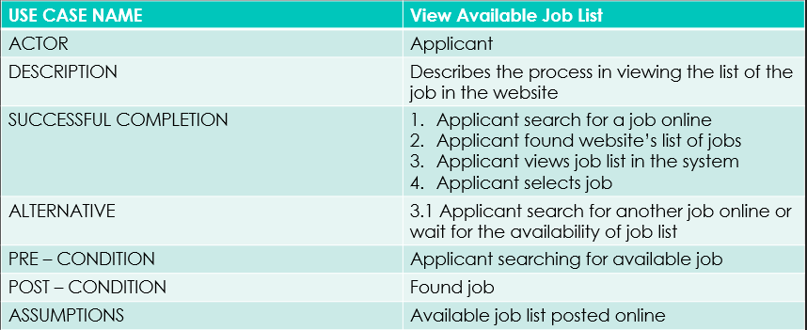

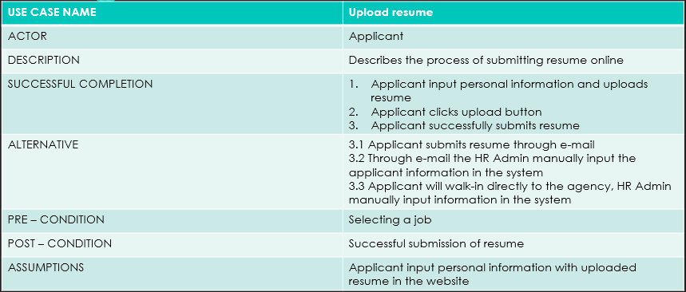

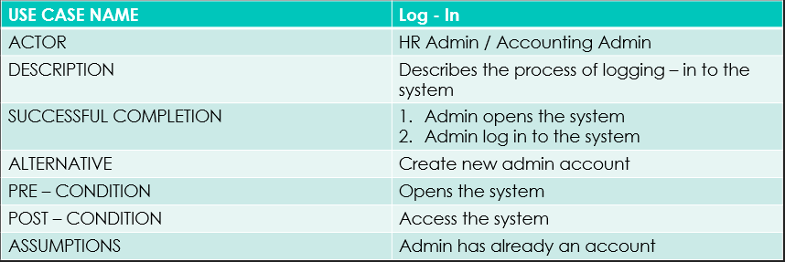

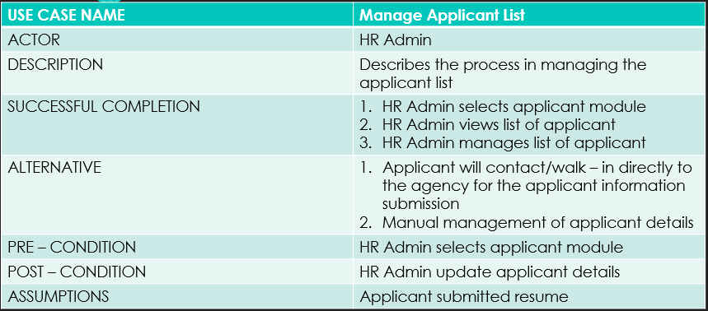

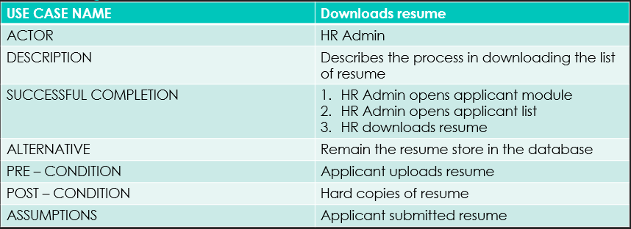

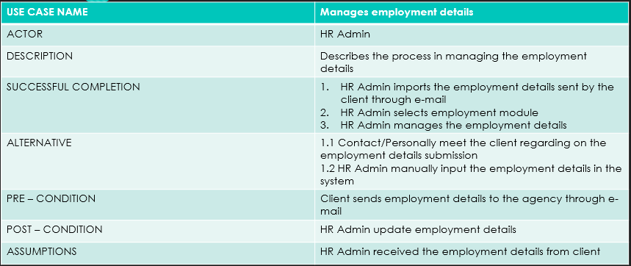

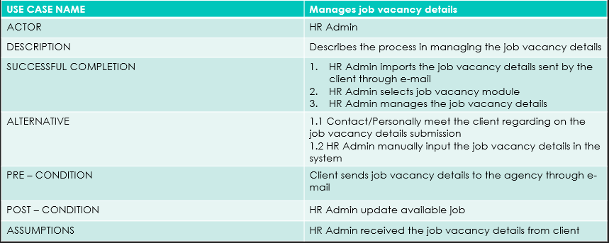

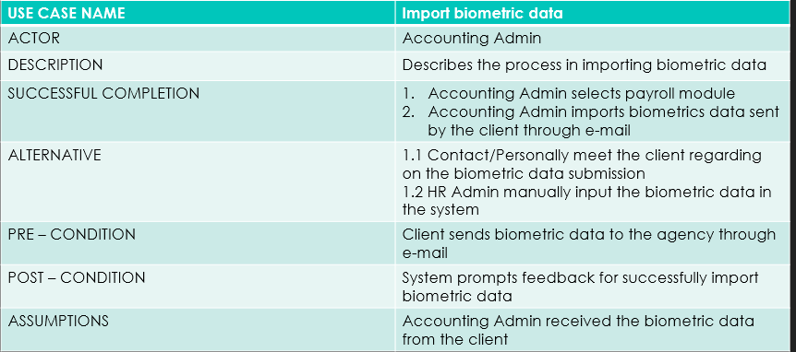

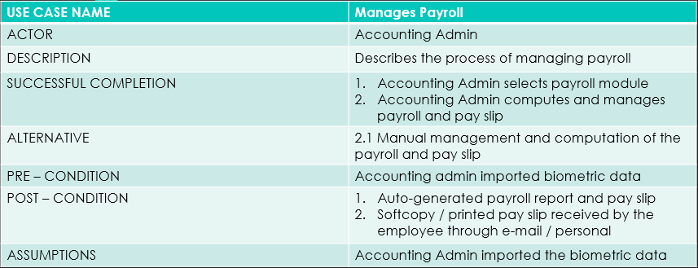

**OBJECT DIAGRAM**

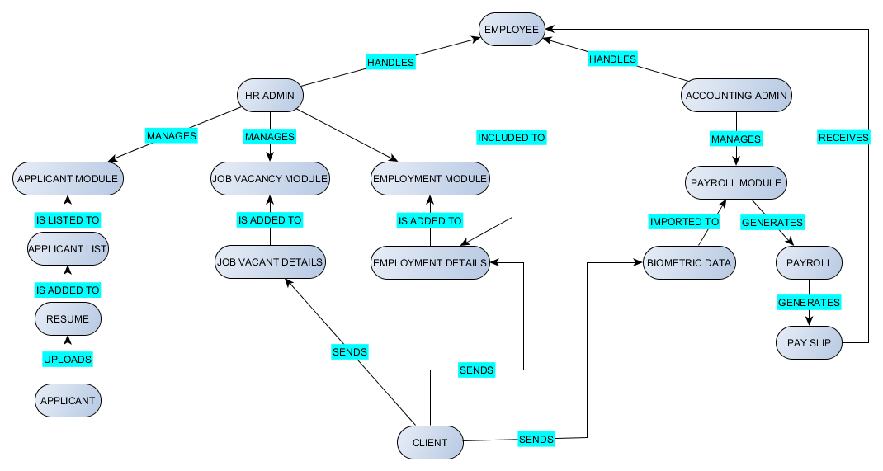

**SEQUENCE DIAGRAM**

**View Available Job / Upload Resume**



**HR Log In / Manage Applicant List / Download Resume**



**HR Log In / Manage Job Vacant Details**

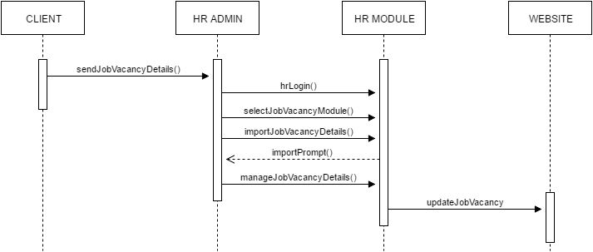

**HR Log In / Manage Employment Details**



**Accounting Log In / Import Biometric Data / Manage Payroll**



**State Transition Diagram**

**Resume**

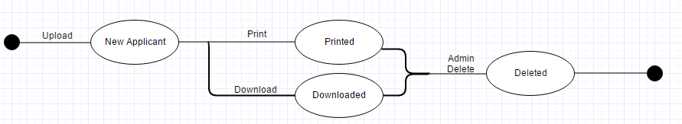

**Admin Accounts**

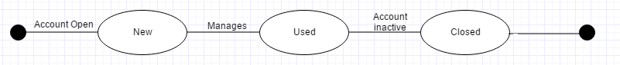

**Biometrics**

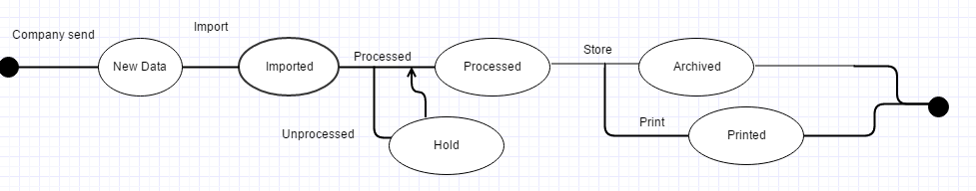

**Applicant List**

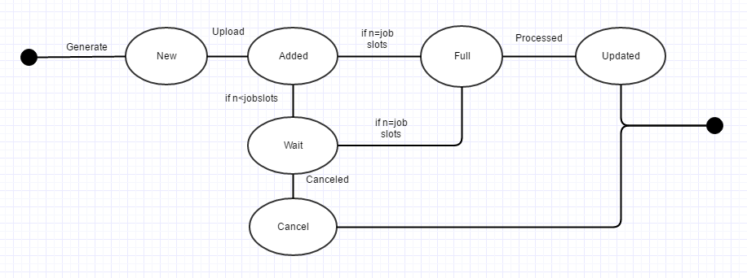

**Pay Slip**

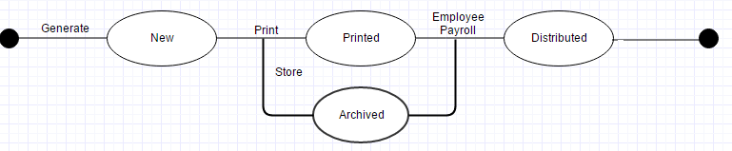

**Activity Diagram**

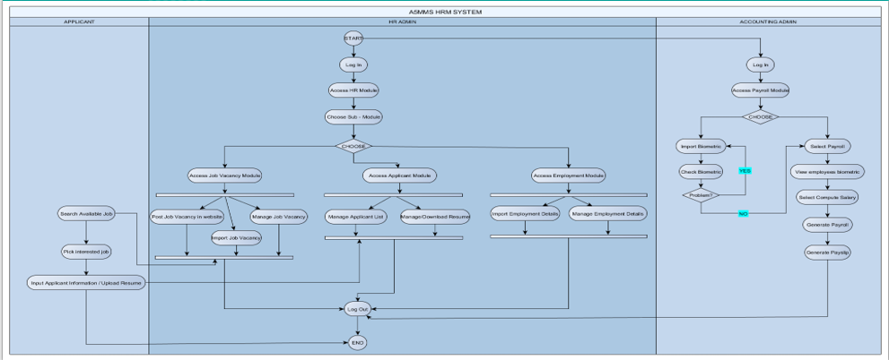

**Software Requirements Specification Checklist**

